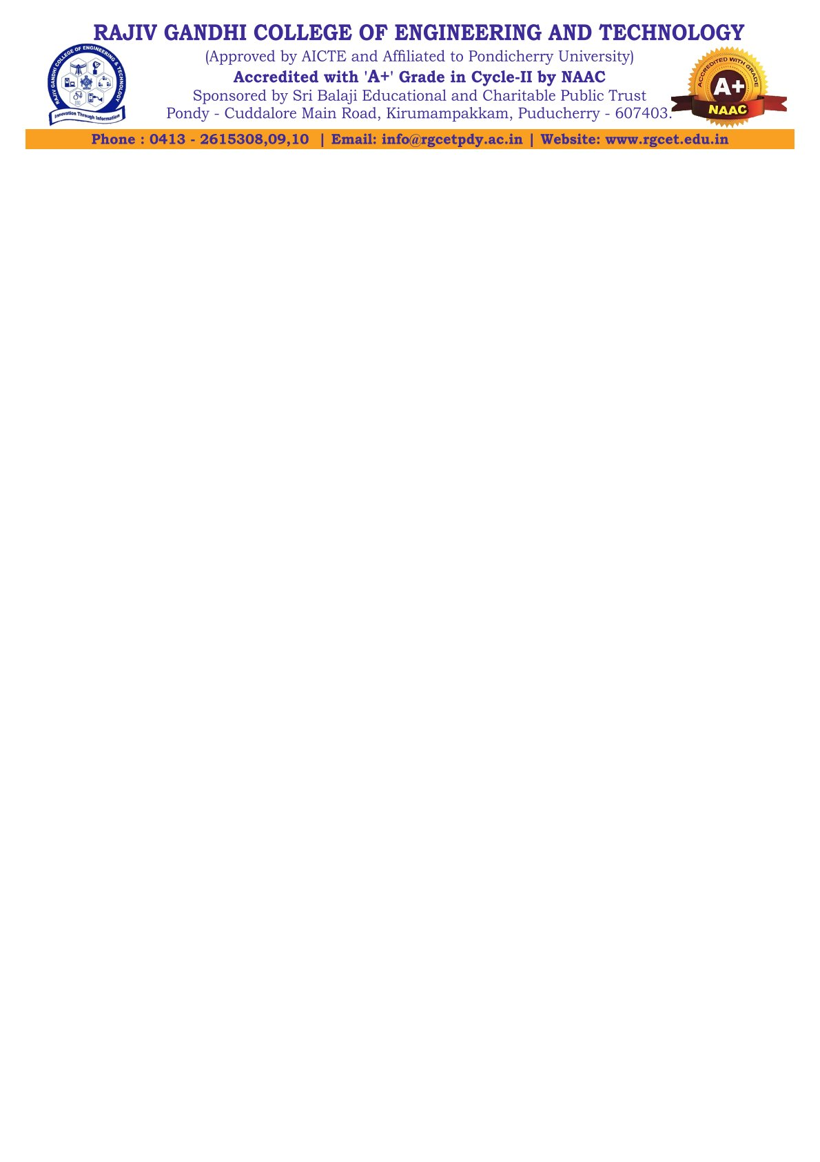

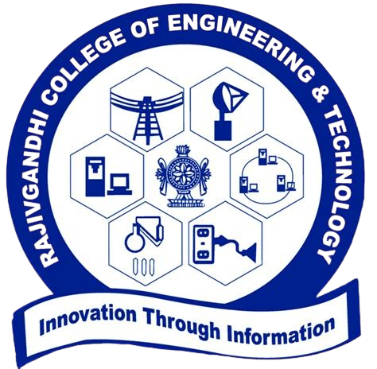
BONAFIDE CERTIFCATE

This is to certify that this is a bonafide record of seminar work done by Mr. MOHAMED B SIRAJUDDEEN, Reg. No. 22TD0053, pursuing Final year, B.Tech COMPUTER SCIENCE AND ENGINEERING in SEMINAR (CS P81) during the academic year 2025-26.

FACULTY INCHARGE HEAD OF THE DEPARTMENT

